Metaheuristic Optimization Algorithm: Design experiments and train models
Bob van Sluijs
A hybrid particle/evolutionary optimizer is implemented to fit a model, or a set of models, to an arbitrary objective function. The implementation is organized into two components in the code:
I. Fitness-landscape and agent tracker
II. Agent
The fitness-landscape module specifies the optimization problem: objective function, number of agents, acceptance criteria, mutation operators (local vs global), and the schedule of communication/recombination. Each agent stores its current parameter vector, fitness value, and trajectory history, as well as the rules governing its moves across the landscape.
Many meta-heuristics have been benchmarked on standardized test functions that define a fitness landscape (e.g., multimodal surfaces with peaks and valleys). The present algorithm defines a search policy over this landscape. Prior work has proposed numerous biologically inspired search policies. Performance depends primarily on the objective function and landscape structure; no single method dominates across all problems. Two features, however, are broadly beneficial: (i) allowing a subset of agents to explore low-promise regions (to escape premature convergence) and (ii) periodic information exchange so that exploration benefits exploitation.

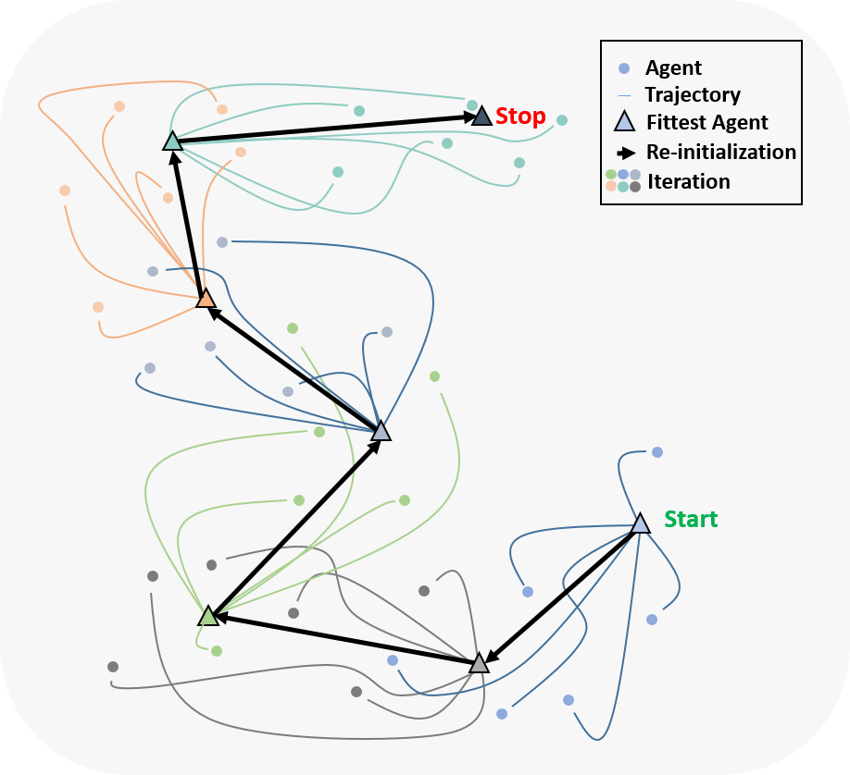
Schema 1. Abstraction of the particle optimization algorithm, the start location of the agents is chosen by selecting the fittest position on the fitness landscape after a Monte Carlo type search (sample 1000 parameter sets). The agents are subsequently mutated shifting their parameter values by perturbing it locally or by applying global perturbations, selecting a new value to a parameter at random. In this process, the agents (circle) move independent from one another, and the agents only move if the mutation improves fitness. After a set number of iterations (default = 20, each color represents an iteration) the agents communicate, the unfit agents coalesce around the fittest agents (triangle). This process is repeated until the agents converge to a local optimum.

Core procedure (defaults in parentheses)
- Initialization
• Sample 1,000 parameter sets by Monte Carlo; simulate and score each.
• Select the top-scoring set(s) as initial agent positions (agents = 10).
- Exploration phase (25 iterations)
• For each agent, propose a mutation:
– Local: shift an index-based parameter by ±1 to ±3 steps.
– Global: reassign an index-based parameter to a random position over its allowed range.
• Accept the mutation only if the score improves; otherwise retain the current state.
- Communication/recombination
• After 25 iterations, reposition underperforming agents toward the current best agent (centroidal or directed “pull”).
• Resume independent exploration.
- Termination
• Repeat exploration–communication cycles until the score fails to improve further (plateau) or a maximum number of cycles is reached.
Mutation operators and sensitivity-guided steps
Parameters are represented by integer indices into a predefined value grid. During model training, kinetic rates (or other estimates) mutate; during OED, control variables mutate. In addition to random local/global moves, a directed mutation uses forward sensitivities of the model output with respect to parameters to ascend the likelihood (or descend the loss).
Multi-model and multi-objective use
Agents can evaluate one or multiple experiments per step. Models and datasets are assigned flexibly: different models can be fit to the same dataset, or multiple models with shared parameters can be fit to different datasets (Schema 2). When a parameter shared across models mutates, each associated model is re-simulated with the updated value. For multi-objective problems, a rank-based selection rule is used across objectives; an agent moves when the new state improves the majority of objectives relative to the previous iteration.
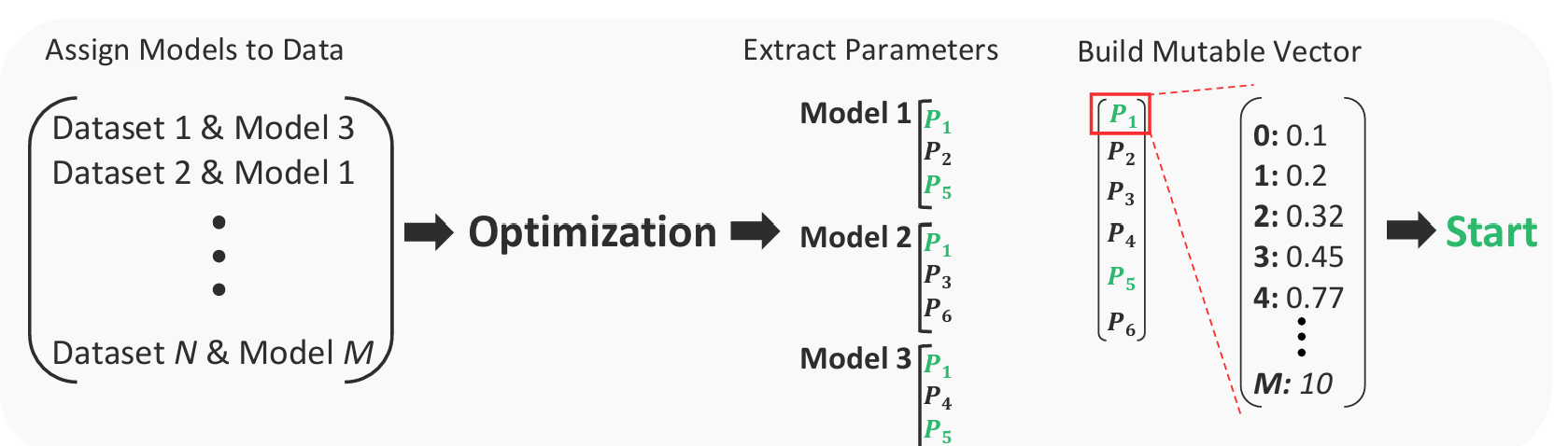
Schema 2. Model–data assignment and mutable vector construction. Models are mapped to datasets. All estimable parameters across the participating models are concatenated into a single mutable index vector. If two models share a parameter, mutations to that parameter’s index are applied consistently to both models, with each model simulated separately to compute its objective(s).

Model Structure
The model itself can be defined by writing out the equations as strings. This template is subsequently processed in a model module. First, the ODEs are transformed reformatted into a matrix, after which we obtain a stoichiometric matrix and a flux vector. Derived from the ODEs original reaction equations this would be defined as
$$\sum_{i=1}^{N}{R_{ij}X_{i}\underset{→}{k_{j}}}\sum_{i=1}^{M}{P_{ij}X_{i}}$$
Were $j ϵ[1,N]$. Thus $R$ and $P$ are $N x M$ matrices representing the number of products in a reaction, respectively, and k is a vector of N reaction rates. Note that any type of kinetic approximation can be applied. This system is subsequently translated to a set of ODEs in matrix format according to
$$\frac{dX}{dt}=Sv(X)$$
Where $S ≜ (P-R)^{T}$ is the stoichiometry of the system and $v(X)$ the kinetic equations in the flux vector. This stoichiometry matrix and flux vector are subsequently used to create an Antimony file (human readable version of SBML, standard biological markup language) using the publicly available Tellurium toolbox. Antimony makes use of reaction equations and fluxes in their standardized notation of models, by creating a flux vector and stoichiometric matrix it becomes easier to translate our original ODEs from text-based equations to antimony. The antimony file is subsequently converted to an SBML file using LibSBML which in turn can be compiled to C++ using AMICI, all intermediate versions of this model are stored in the model module, the general process is shown in schema 1. Finally, the module already defines the parameter space by building a (uniform)logarithmically spaced vector $V$with $n$ the size of the vector (1000). The individual parameters $V_{i}=$ $10^{θ_{i}}$where $θ_{i}$ is sampled from a uniformly distributed vector $θ$.
$θ =\{r:r ∃i ϵ N such that r= log_{10}\left(α\right)+\frac{log_{10}\left(β\right)}{n}i, and r ϵ \left[log_{10}\left(α\right),log_{10}\left(β\right)\right)\}\}$
where α and β, the previously defined upper and lower bound of a parameter. This means that each possible value of a model parameter altered or fixed by the fitting or OED algorithm, has a corresponding integer index.
To integrate experimental data (or simulated in silico data), experiments are defined as a separate module. The data is parsed into data vectors. The conditions of the experiments are passed along as a separate vector, this includes both initial conditions and time dependent inputs. The latter are defined as separate arrays:
$$t_{start_{1}}→t_{end_{1}}|{ U}_{1}=x_{i}…U_{n}=x_{n}$$
$⋮$
$$t_{start_{m}}→t_{end_{m}}|{ U}_{1}=x_{i}…U_{n}=x_{n}$$
Where each time window $t_{start}→t_{end}$ up to the final time window $m$ has a unique value for each control input $U$ (the time window itself is user defined). Finally, if no experimental data is available, the option exists to generate the data in silico by adding noise to the simulated outcomes from the model module and redefining it as a measured vector. Any model can be combined with any measurement object to form a dataset.
Next, we build a solver module that can simulate the ODEs in different formats, notably this solver needs to be capable of simulating the time dependent inputs, we utilize a start/stop approach. The model solver takes the model module and the measurement object and simulates the system. If it cannot find an AMICI object, Tellurium will be used, if that is lacking Scipy’s integrate (LSODA) will be used, if no measurement object is provided the control parameters will default to predefined values.

User Interface
Overview. Code excerpts illustrate a minimal, end-to-end use of the software. Users can (i) define an ODE model manually in a standalone Python file or (ii) generate one via a provided model-builder (not shown). Naming conventions must be consistent across state variables, kinetic parameters, and control inputs.
Flux-term parsing rule. We adopt a single syntactic rule to identify flux terms when we define a set of equations manually. Within the model expression, additions and subtractions are explicitly delimited as |+| and |-|. Any substring between two delimiters is parsed as one flux term and mapped to the flux vector. Text not enclosed by these delimiters is not treated as a separate flux i.e. if we split our function $\dot{x}=f\left(x,u,ϴ\right)$ into a stoichiometric matrix and a flux vector $\dot{x}=Sv$(X)..
Workflow. The model file (Fig 1) declares the ODEs and assigns symbols to categories (state, parameter, control). The main script (Fig. 2) imports and compiles the model, defines experiments (measured or simulated—either randomly perturbed or optimally designed), and assembles a dataset as a dictionary that maps each experiment to its corresponding model instance. This dataset is then passed to modules for (i) structural/Practical identifiability (e.g., SVD-based analyses), (ii) parameter-sensitivity correlations, (iii) PCA of sensitivities, and (iv) parameter estimation. The current fitting routine reports empirical distributions per rate constant as boxplots rather than absolute likelihoods. A
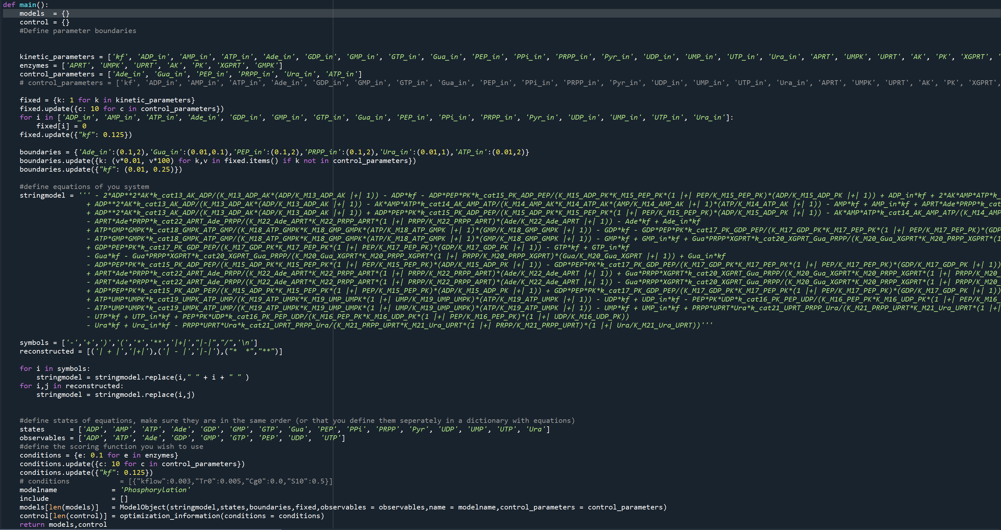
Figure 1 | Model definition file used by pyKinextra.
A standalone Python file specifies the ODE system and tags each symbol as a state variable, parameter, or control input. The file also uses the |+| and |-| delimiters so that flux terms are correctly parsed and mapped to the flux vector in Sv(X).

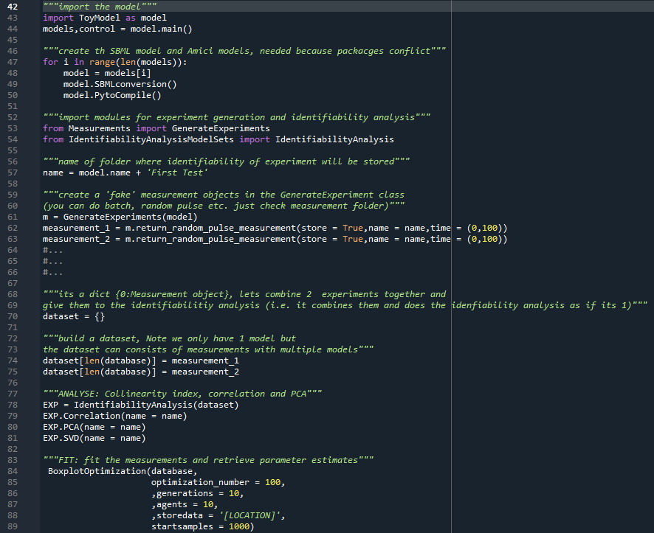
Figure 2 | Main script for compilation, experiment setup, and analysis.
The script imports and compiles the model (restarting the session if needed to resolve package import-order conflicts), constructs two example experiments (here, simulations generated by randomly varying control inputs), assembles them in a dictionary, and runs identifiability (SVD), parameter-sensitivity correlation, and PCA analyses. Parameter estimation returns boxplots for each fitted rate constant.

